*The Great Gatsby* Literary Insights

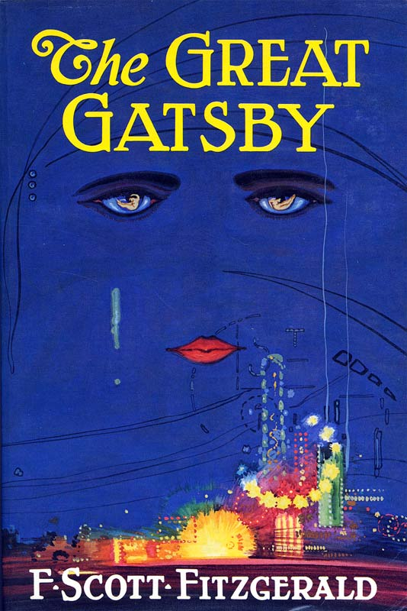

*Do this sheet for each chapter. Please hand write these rather than typing them if possible. Copy lots and lots of my wording to try it on for size. Use* [***The Stop! Sheet***](http://www.mrmooreismyteacher.com/ENG4U1/Docs/Stop.docx)*.*

1

To Start With

Make a **title** for the chapter. It should show that you understand the chapter enough to be able to title it. (e.g. **Chapter 4: Daisy Rents a Plane**.)

Write a **mini plot summary.** Using more than two sentences will result in a mark deduction. You must start with the words “Fitzgerald employs chapter __ to depict…” Use literary present tense with “ing” to describe what is going on (“saying” or “going.” Not “~~said~~” or “~~went~~.”)

2

Purpose of Chapter/Authorial Views *(Use section* ***4*** *to back up these points)*

Do one of these per chapter. Identify a major point or topic that the author is addressing with this chapter. First you will claim that he is doing this, wording the issue as an issue or topic, rather than a question. (No question marks and no “5 Ws” question words) Then you will say what *exactly* Fitzgerald (clearly) thinks about this issue that must have been important enough to him that he wrote a book about it.

*Some Choices:*

* Are the rich nothing more than pretty, powerful but pointless parasites?
* How much should people build and live lives designed mainly to impress others?
* Are material, financial and social success sufficient to give your life meaning?
* Do right and wrong really matter?
* Are the wealthy “above the law?”
* What does it mean for you to “be alone in a crowd?”
* What can material success cost you?
* Is the pursuit of happiness, and of the American Dream in general, not a lofty enough goal for you? Do you need more?
* Does society tell you who you are?
* Does America have an old money/new money caste system, and an aristocracy?

*Note that I have annoyingly worded these as questions, leaving them for you to reword as topics. I have also liberally used “you,” (and “your”), which words you are absolutely not allowed to use in this assignment). You must use the fill-in-the-blank structure below, with my exact wording:*

Chapter *4*  enables Fitzgerald to explore[1] the larger issue of *the importance of eating fibre regularly.* He is clearly presenting the idea that *although eating fibre is terribly important, sometimes people have to eat some meat as well.* This idea is then developed throughout *The Great Gatsby*.

Go on to add an explanation to the end of this claim, mentioning specifics from the chapter, that make it clear that Fitzgerald really does seem to be exploring this idea in chapter 4, and that you aren’t simply making stuff up:

... *meat as well. Fitzgerald three times mentions John eating a bran muffin, first at the baseball game, and then later at the horse races. He also, however, eats a hotdog while he is there. All of this makes Fitzgerald’s views as to a healthy diet for the wealthy upper class very clear to the reader.*

3

The Writer Being Artful (Use section 4 to back up two of these three points)

*Do one each of* ***a, b,*** *and* ***c*** *for each chapter, using the fill-in-the-blank structure and a new paragraph for each one, to talk about authorial choices:*

1. Characterization (personality):

The characters in *Gatsby* are often amoral and superficial, lacking any kind of virtue or moral compass. They are also bored and vainly in search of having a point to their “successful” lives. Talk about that.

* **(For a new character):** Chapter 3 sees Fitzgerald introducing the readers to *Jessica*, who seems *rude and aggressive*. *This makes the reader wonder why Nick likes Jessica.*
* Fitzgerald *(begins to establish/further establishes)* that *Nick* is *an angry person*.
* Fitzgerald here presents *Nick* astaking important steps toward fulfilling his goal of *finding things to do to fill in all of his ample free time.* *He purchases a BMX bike, which he rides in the town square, among the pigeons. This makes the reader remember that Nick has nothing else to do.*

1. **Setting:**

* Fitzgerald is known for using place, especially landscape and weather, to convey the inner landscape of the characters in his writing. (*include these exact words ^ in your analysis*.)
* Fitzgerald frequently uses his descriptions of the landscape, and of the places people live and work, to instill a lingering mood in the reader. (*include these exact words ^ in your analysis*.)

(Back it up like this: When Fitzgerald writes that *winter has come, with a biting wind,* this reveals *Gatsby’s* thoughts and feelings at this point. *Gatsby is facing financial ruin, and his future looks as bleak as the view out the window of the house he will soon no longer be able to afford.* This makes the reader *feel sympathy for Gatsby.*

1. **Recurring Symbols/Imagery:**

You must use a direct quotation from the book every single time you cite something in the **Recurring Symbols/Imagery** section. Quotes from this section are going to be used in **The Recycled Essay** assignment, so quote away. In *Gatsby*, Fitzgerald makes endless, unsubtle use of the following:

* **Floral imagery**, especially to discuss Daisy “Flower Name” Buchannan, who is like a hothouse orchid; drooping, pretty, all white and gold, but ultimately she can only function as an expensive decoration. Other women also offer floral imagery in the book. Clothes, too.
* “**Money colours**,” mainly silver, gold and green. Also copper and nickel. The book is about displays of wealth, both old money and nouveau riche.
* **Automobiles**. These are status symbols for the wealthy, and also show problematic use of mobility, money and power, in how they are misused. *If you do this one, tell whether the automobile is mainly showing power, money, mobility or misuse of same*.
* The fading, painted **eyes of Dr. T. J. Eckleburg**, which seem to watch, but don’t see or do anything. Eckleburg makes one think Fitzgerald is presenting a painted God who is now a thing of the past, certainly not actually watching, or if so, not intervening or playing any part in the lives of the godless, superficial characters.

Back it up like this: When Fitzgerald writes that Daisy wears *“ a green dress, green as a dollar bill and as crisp,”* he is once again employing the *money* imagery with which *The Great Gatsby* is so rife. (I’m actually looking for a correct use of the word “rife,” here.) This makes the reader associate Daisy with old money, and understand why Gatsby is attracted to her. (I’m actually looking for a “this makes” **So What** statement here.)

4

Backing Up Your Points

For sections 2 and 3, you are going to claim a number of things both about how Fitzgerald put the novel together, and about what specifically he is saying with it.

Things rather like:

Fitzgerald is suggesting the American Dream is not achievable for just anybody, unless they cheat or are unusually lucky.

Things almost, but not exactly, like:

Fitzgerald is choosing to make Gatsby’s car the same colours as the Canadian five dollar bill to further associate Gatsby with money and exotic things.

Things precisely like:

Fitzgerald has the weather and seasons in *Gatsby* reflect the mood of his characters.

Well, you’re going to need to back statements like these *up*. You need to support your claims. You can’t just claim claims and expect to be believed with no evidence. Vital to demonstrate that you’re not just imagining or making all of this up, but that there is some support in the actual book for what you’re saying it does and says. Otherwise you’re wasting your time. So use *one* or *both* of two methods:

1. Quotation

This is the strongest, simplest way to make yourself look right. You start a sentence, and have Fitzgerald himself, from beyond the grave, finish your sentence for you. How right does *that* make you look? You do the first half, he does the second:

Fitzgerald is choosing to make Gatsby’s car the same colours as the Canadian five dollar bill. When Fitzgerald introduces the car, he writes that the car is “cream coloured, decorated with nickel and with a bright, Tardis-blue interior that [strikes Nick][2] as both expensive and quintessentially Canadian.” (p 89)

Note that you start with Fitzgerald’s name (never simply saying “the author”) and the book’s title (never simply saying “the novel”). If in a paragraph you have named both, subsequent sentences in that one paragraph may resort to pronouns like “he” and “it.” Also note that **when quoting bits of dialogue**, conversations are very awkward to try to quote, due to changing speakers. So **don’t**.

1. Explanation

To do this, once you’ve made a very specific claim, you will then make very specific reference to very specific things in the novel itself. You may, if absolutely necessary, make very brief, very specific reference to an event that happened in the book. You may *not* go on for more than perhaps two sentences, simply retelling an entire scene. Don’t retell a scene from the book in detail. Be as concise as you can.

Fitzgerald uses chapter 16 to explore the idea that material, financial and social success are insufficient to give a person’s life meaning. This is evident when Fitzgerald describes Nick going uptown and buying opium, to try to give his life whatever it is currently missing. A recovering addict, Nick is now about to fall off the wagon, causing more trouble for the whole affluent, old money social circle of which he has become a part.

5

Exemplar

Do each chapter analysis just like this (only don’t make up stuff that’s not in the book). Recording page numbers for the quotations will enable you to find them later for *The Recycled Essay.*  Submissions looking for level 4 marks should be no shorter and no longer than this:

Chapter 18: Party In The U.S.A.

Fitzgerald employs chapter 18 to depict a party being held at the Buchannan’s estate, after Gatsby has been elected President. Tom and Daisy are drinking heavily throughout, while arguing with anyone who will listen about how they knew Gatsby before he even considered running for government, but Nick misses the entire party because he is taking a nap.

Chapter 18 enables Fitzgerald to further explore the larger issue of the importance of eating fibre regularly in the lives of the American upper class in search of the American Dream. He is clearly presenting the idea that although eating fibre is terribly important, sometimes people have to eat some meat as well. This idea is then developed throughout The Great Gatsby. Fitzgerald three times mentions John eating a bran muffin, first at the baseball game, and then later at the horse races. John also eats a hot dog, however. Just as in chapter 2, which presented the idea that fibre with some meat was a cornerstone of Mr. Pettigrew’s health regime, Fitzgerald continues in chapter 18 to present the importance of fibre and meat, not only for Mr. Pettigrew, but for Mrs. Havershaw and Madame Tusside as well.

Fitzgerald is known for using place, especially landscape and weather, to convey the inner landscape of the characters in his writing. When Fitzgerald writes that “winter [has] come, with a biting wind that [tears] at people’s faces,” (p 123) this reveals Gatsby’s thoughts and feelings at this point. Gatsby is facing financial ruin, and his future looks as bleak as the view out the window of the house he will soon no longer be able to afford. Gatsby’s time in the sun is well and truly over.

When Fitzgerald writes that Daisy wears “a green dress, green as a dollar bill and as crisp,” (p 128) he is once again employing the money imagery with which *The Great Gatsby* is so rife. Fitzgerald is here using the colour green to clearly connect the famously wealthy Daisy Buchanan with money, American paper bills being printed entirely with green ink.

Gatsby’s expensive car is a vintage Canadian Laurier Beaver sedan. Fitzgerald is, therefore, choosing to make Gatsby’s car the same colours as the Canadian five dollar bill. When Fitzgerald introduces the Beaver for the first time, he writes that the car is “cream coloured, decorated with nickel and with a bright, Tardis-blue interior that [strikes Nick]as quintessentially Canadian.” (p 119) The nickel colour of the Laurier’s trim calls to mind actual Canadian nickels, with their pictures of a beaver stamped into the metal. Fitzgerald is yet again employing the money imagery with which *The Great Gatsby* is so rife, in this case throwing an exotic Canadian spin into the mix. This makes Gatsby seem interesting and Canadian.

1. If you have already mentioned Fitzgerald exploring this in a previous chapter, it can make you sound very clued in to say “...enables Fitzgerald to further explore”. A call-back to that previous chapter, in your explanation, will make you sound very on your game: “Just as in chapter 2, which presented the idea that fibre was a cornerstone of Mr. Pettigrew’s health regime, Fitzgerald continues in chapter 4 to present the importance of fibre, not only for Mr. Pettigrew, but for Mrs. Havershaw and Madame Tusside as well.”
2. Note that the fictitious paragraph from *The Great Gatsby* would have originally been worded:

   Gatsby’s automobile glided out from his opulent garages and we all admired it. The car was a Laurier Beaver sedan. It was cream coloured, decorated with nickel and with a bright, Tardis-blue interior that struck me as both expensive and quintessentially Canadian. It was magnificent. Daisy swooned with pleasure at the very sight of it, falling into a hedge and dropping her gin and tonic as she did. Tom grunted with equal parts displeasure and jealousy.

   The essayist has started quoting at a comfortable point in the sentence from the novel, and has used [square brackets] to indicate that she has monkeyed with the wording somewhat (but not too much) to make the quote fit the flow of the sentence already underway.